Key questions  - How many seasons are in year and what are they called?  - What are the features of each season? | Key vocabulary  autumn: a season of the year when the weather begins to get colder. The leaves start to fall. The amount of daylight becomes less. This means that the daytimes are shorter and night times are longer.  daylight: this is when it is light outside. The amout of daylight changes with each season.  summer: a season of the year when the weather gets hotter. The daytime is long and the nights are short. Summer has the longest days.  spring: a season of the year when the weather starts to get warmer. The daytimes start to get longer.  weather: this includes the temperature outside, the wind direction and strength, as well as rain, cloud, snow and sun.  winter: a season of the year when the weather is much colder. Sometimes it is cold enough to freeze, leaving frost and ice on the ground. The daytimes are shortest in the year and the night times are the longest.
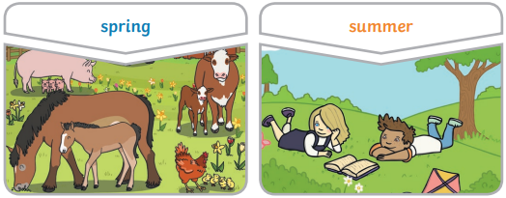
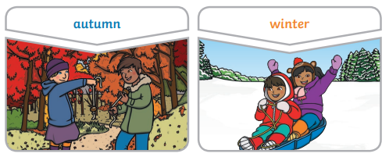
Key Knowledge

autumn: September, October, November
winter: December, January, February
spring: March, April, May
summer: June, July, August

