**Knowledge Organiser EYFS Term 5 Topic: Buildings**

This topic supports children to identify a range of local and international building types and their uses, and some materials. Big Question: What makes a good building?

**Vocabulary**

Build

Construct

Materials: brick, cement, wood, glass, tiles, clay, stilts

Feature

Design

Architect

**Key Knowledge and skills**

Know some materials used in local and British building, now and in the past

Identify some buildings and materials used in other countries

Identify different types of buildings in our local environment

Name some basic features of all buildings

Name some unique features of particular buildings

**Books**

The Three Little Pigs

On Sudden Hill

This is our house

Iggy Peck Architect

Boxitects

A Place Called Home

Let’s Build a House

How a House is Built

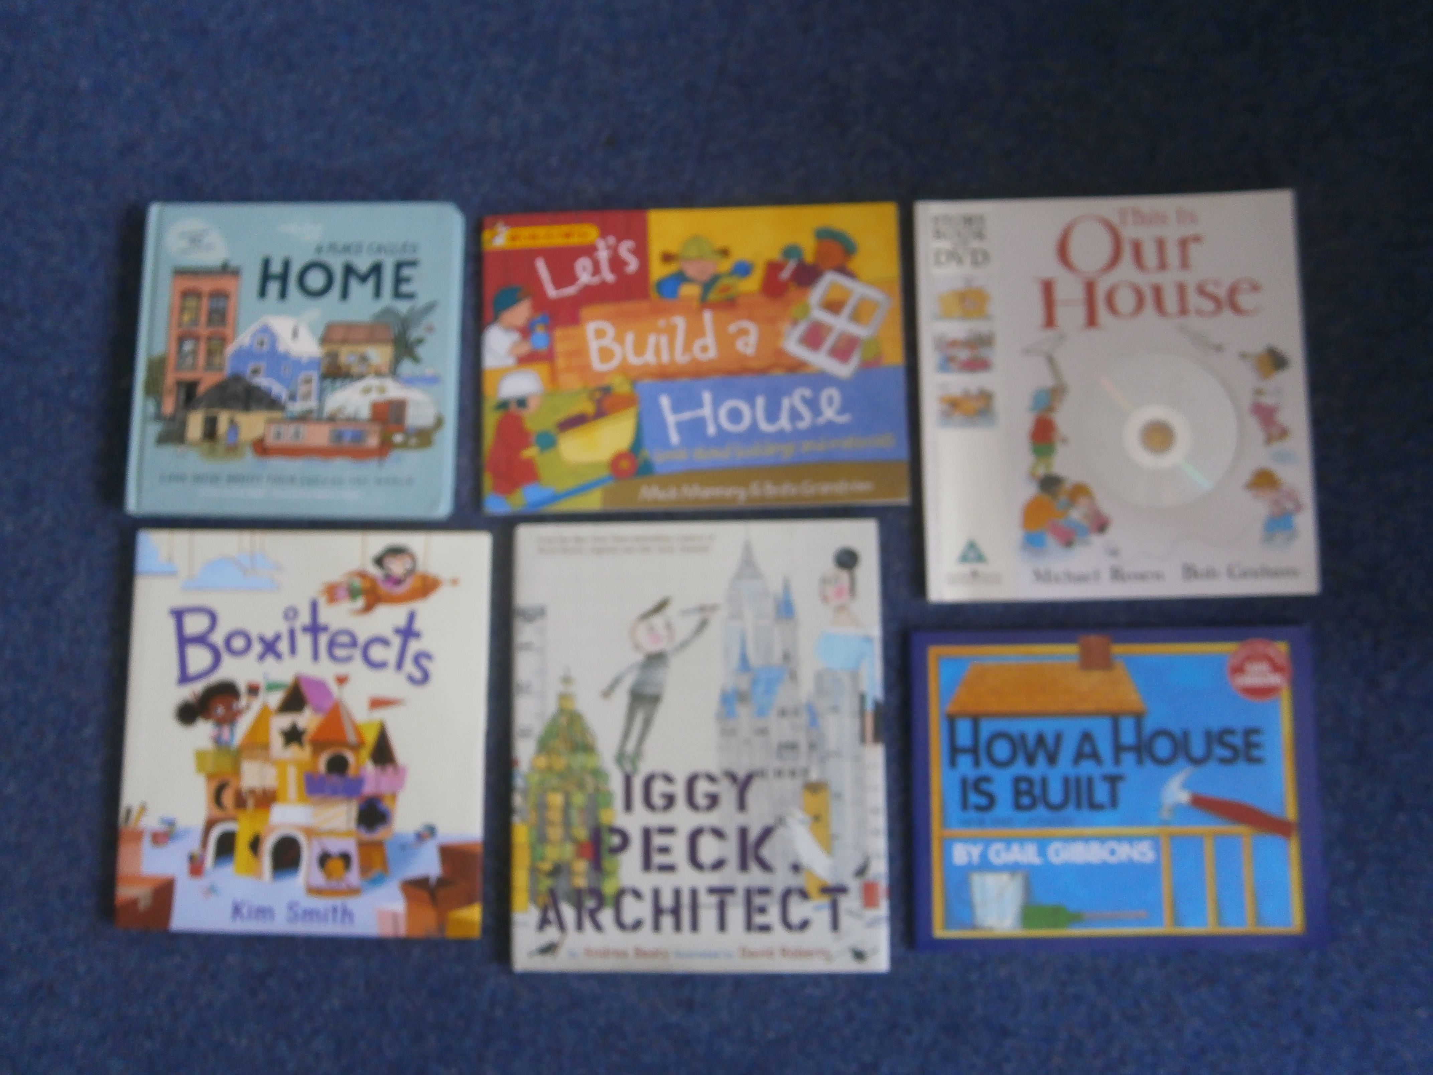

**Links to future learning**

EYFS To compare the world’s environments and people

KS1 History Great Fire of London, Tattershall Castle

LKS2 History Romans

KS1 Geography Africa, China

LKS2 Geography Brazil, Antarctica